  
Systems and Software Requirements Specification

**Date:** 24-Jan-2011  
**Project Managers:** Matthew Kimber & Austyn Mahoney  
**Team:** Dahln Farnes, Cameron Harp, Peter Lister, JD Russell, Kevin Russon, Brian Sneddon  
**Sponsor:** Prof. Richard Fry  
**Client:** Korle Bu Teaching Hospital & Martin Luther King Memorial Clinic  
**Website:** http://kaizen.matthewkimber.com/

Contents

Preface 4

Version History 4

Introduction 5

System Requirements Specification 6

Functional Requirements 6

Non-Functional Requirements 7

System Architecture 10

Use Cases 11

UC-01 - Create Patient ID Card 11

UC-02 - Generate Physical Patient Record 13

UC-03 - Maintain Patient 15

UC-04 – Search Patient Records 17

UC-05 - Admit Patient 19

UC-06 - Discharge Patient 20

UC-07 - Record Patient Vitals 21

UC-08 - Create New Encounter 22

UC-09 - Add Notes to Patient Record 23

UC-10 - View Patient History 24

UC-11 - Maintain Patient Allergy 26

UC-12 – Invoice Product/Service 28

UC-13 – Generate Bill/Invoice 30

UC-14 - Record Payment 31

UC-15 - Maintain Product/Service 32

System Models 34

Registering a Patient 34

Record Patient’s Vitals 35

Visit with Physician 36

User Interface Mockups 37

Add Patient to System 37

Search for Patient 41

Take Patient Vitals 43

Issue Medications 44

Bill Patient 45

View Pharmacy Inventory Report 46

View Pharmacy Sales Report 47

View Clinic Income Report 48

Select Patient to See 49

View/Add Patient Records 51

View/Make Diagnosis 52

Prescribe Medicine 53

User Effort Estimation 54

Search for Patient 54

Add Patient to System 54

Take Vitals 55

Bill a Patient 55

Select Patient to See 55

Add a Patient Record 57

View/Make Diagnosis 57

Prescribe Medicine 57

Signatures 59

Preface

The purpose of this document is to define the functional and non-functional requirements associated with the details and behavior of the proposed software system. It will explain the processing and performance of the system as well as help in refining requirements as requested by stakeholders and potential users.

Version History

|  |  |  |
| --- | --- | --- |
| **Date** | **Description** | **Author(s)** |
| *8-Jan-2011* | Initial manual merge of the two SSRS documents. | JD Russell |
| *9-Jan-2011* | Added some formatting and table of contents. | Matthew Kimber |
| *16-Jan-2011* | Made changes to glossary and use cases | Austyn Mahoney |
| *19-Jan-2011* | Added and edited use cases | Austyn Mahoney |
| *22-Jan-2011* | Renumbered use cases and added diagrams. | Matthew Kimber & JD Russell |
| *24-Jan-2011* | Cleaned up the document for final approval. | Matthew Kimber |

Introduction

Korle Bu Teaching Hospital is a large medical facility in Ghana, Africa. The hospital is comprised of several buildings spread across a large campus. Currently, their medical records are tracked using logbooks and paper charts, which are stored in a central records facility.

The Martin Luther King Memorial Clinic is a small medical practice located in Ghana, Africa. The staff there is currently using paper processes to manage all their information. They are currently storing and tracking most of their medical and administrative information in paper formats as well.

In both cases the current paper systems lead to many inefficiencies and errors. In many cases this affects the quality of patient care that both facilities are able to offer. For this reason a software system has been commissioned to help improve the efficiency and accuracy of the staff and raise the quality of service for patients in both facilities. The goal of this project is to develop a solution that can be used at both locations and possibly other medical facilities in the future. The proposed Electronic Healthcare System (EHS) will be composed of the functional and non-functional requirements specified within this document. Requirements for the EHS have been derived from the initial customer request and may require further expansion as more requirements of the system are discovered.

In order to accommodate the transition that must take place from a paper record to an EHS, there are two parts of the proposed system. The first part of the proposed system will allow for more efficient tracking of existing paper records. And the second half will allow for the capture of health information such as vital statistics, allergies, general notes, and diagnoses per patient. The system will also be capable of generating reports that provide facility administration and governmental organizations with statistical data relating to hospital and clinic operations. Both facilities can benefit from an increase in operational efficiency, which will allow staff to focus more on the care of patients and less on the manual work involved in keeping physical records.

System Requirements Specification

Functional Requirements

1. The system shall provide a user interface for physicians, nurses, and other staff members.
2. The system shall allow new patients to be added to the system.
3. The system shall allow a patient’s personal information to be edited.
4. The system shall allow a patient to be removed from the system only by a physician.
5. The system shall permit the receptionist to print a new patient information sheet for the patient to fill out personal information and previous medical history.
6. The system shall allow data entry of the information given to the receptionist by the patient via the patient information sheet.
7. The system shall permit the receptionist to check-in a patient upon arrival to a specific department.
8. The system shall permit the receptionist to maintain patient information at check in.
9. The system shall allow nurses to record the vitals of a patient.
10. The system shall have the ability to record a patient’s medical history.
11. The system shall allow a physician to review a patient’s medical history.
12. The system shall allow a physician to add information to a patient’s medical history.
13. The system shall allow a physician to edit information in a patient’s medical history.
14. The system shall allow a physician to remove information from a patient’s medical history.
15. The system shall allow physicians to record diagnoses of patients.
16. The system shall allow physicians to record notes regarding a patient.
17. The system shall allow physicians to prescribe medication for a patient.
18. The system shall allow the staff to pull up prescription orders for a patient.
19. The system shall allow a staff member to accept payments for services provided to a patient.
20. The system shall allow a staff member to accept payments for medication sold to a patient.
21. The system shall allow a staff member to accept payments for supplies (i.e. bandages, etc.).
22. The system shall track pharmacy inventory.
23. The system shall track supply inventory.
24. The system shall have the ability to generate and print reports on pharmacy inventory.
25. The system shall have the ability to generate and print reports on supplies inventory.
26. The system shall have the ability to automatically generate weekly pharmacy inventory reports.
27. The system shall have the ability to automatically generate weekly clinical supply inventory reports.
28. The system shall allow for the generation of clinical activity reports.
29. The system shall allow for the generation of clinical income reports.
30. The system shall have the ability to automatically generate weekly activity reports.
31. The system shall have the ability to automatically generate weekly income reports.
32. The system shall have the ability to check patient records out to a specific location.
33. A staff member merges two patient records.

Non-Functional Requirements

1. The system shall support different security roles and permissions for the physicians, nurses, and clerical staff.
2. The system shall be designed as an *n-tier* architecture for scalability.
3. The system shall have a *database* that will be used for information storage.
4. The system shall provide a server used to store *binaries* and related data.
5. The system shall be reliable; crashes and critical errors will be rare or non-existent.
6. The system shall be easy for non-technical users to learn and use.
7. The system shall respond quickly, without *lag*.
8. The system shall have measures for ensuring data integrity in the case of *environmental* or *hardware failures*.
9. The system shall be designed to work in a networked environment of at least two computers.
10. The system shall have the ability to scale up to at least 10 *client computers*.
11. The system shall be compatible with an *operating system* of Windows XP or greater.
12. The system shall create a *backup* each day.
13. The system shall be capable of retrieving data via laser scanner.

**Glossary of Terms**

Client Computer: A computer connected to the *server*. This computer allows staff to access the software and interact with the data stored on the *server*.

Communication (System Architecture): This is the module that handles the communication between the *server* and the *client computers*.

Data (System Architecture): This is the module that allows for the retrieval and storage of data entered by users. The main purpose of this piece of the *system architecture* is to interact with the *database*.

Database: A software system for efficient data management on a computer.

Domain (System Architecture): This is the module that defines the problem and the associated elements. An example of this would be the idea of a *patient* or *prescription*.

N-Tier: A system for developing software that divides up the aspects of the system among: data access, server processing, and presentation.

Operational Management (System Architecture): This is the module that records important information about the system. This system is useful when troubleshooting problems within the software.

Presentation (System Architecture): This is the module of the software that allows a user to visually interact and manipulate the stored data.

Security (System Architecture): This is the module that performs security checks on user access. For instance a *receptionist* or *clerk* may not be able to see the data a *physician* can see within the system.

Server: A central computer that stores data and performs computing over a networked connection.

Software: Computer programs that perform specific functions.

System: The software to be developed and all of its associated parts.

System Architecture



Use Cases

UC-01 - Create Patient ID Card

During the creation of a new patient or for a returning patient an identification card is generated from the given information and presented to the patient. This card serves as an identifier for quick look-up of patient information and speeds up the process of check-in.



|  |  |
| --- | --- |
| **Identifier** | UC-01 |
| **Description** | Process to create a patient ID card. |
| **Actor(s)** | Receptionist |
| **Preconditions** | Patient does not have current ID card. (Either patient is newly registered or patient lost ID card.) |
| **Flow of Events** | 1. The staff member selects print patient ID card. 2. The card is printed. 3. The staff member gives the patient the new ID card. |
| **Post Conditions** | Patient now has ID card. |

UC-02 - Generate Physical Patient Record

For certain purposes the facility would like to keep a physical copy of the patient’s chart or record. A receptionist, nurse, or physician can produce this record while viewing the patient’s information.



|  |  |
| --- | --- |
| **Identifier** | UC-02 |
| **Description** | Process to generate a physical copy of a patient record. |
| **Actor(s)** | Receptionist, Nurse, Physician |
| **Preconditions** | A digital record exists in the system for the patient |
| **Flow of Events** | 1. The user searches for an existing patient record. 2. The user selects to print a physical copy of the record. 3. A physical copy is printed with a date/time stamp to identify how recent the physical copy is. |
| **Post Conditions** | A physical copy of the patient record is created. |

UC-03 - Maintain Patient

For a patient to be treated in the hospital they must have an accurate patient record. When a patient is seen for the first time a staff member must create a record. For subsequent visits, information needs to be updated in order to maintain an accurate record.



|  |  |
| --- | --- |
| **Identifier** | UC-03 |
| **Description** | Process to register a new patient or update an existing patient. |
| **Actor(s)** | Receptionist, Nurse, Physician |
| **Preconditions** | N/A |
| **Flow of Events** | 1. Staff member searches to see if patient already has record in system. 2. Staff member selects record to modify. 3. Staff member enters patient’s information. |
| **Alternative Flow – New Patient** | 2a. Staff member selects option to add new record. |
| **Alternative Flow – Delete Patient** | 3a. Physician or administrator selects option to deactivate patient record.  3b. User is prompted to confirm action.  3c. Patient is marked inactive in the system. |
| **Post Conditions** | The patient has an up to date record in the system. |

UC-04 – Search Patient Records

The receptionist or another staff member needs to search the system for a particular patient. This can be done using various data provided by a potentially existent patient.



|  |  |
| --- | --- |
| **Identifier** | UC-04 |
| **Description** | A staff member searches for a patient based on previously provided demographic information. |
| **Actor(s)** | Receptionist, Nurse, Physician |
| **Preconditions** | N/A |
| **Flow of Events** | 1. Staff member enters search criteria into the system. 2. Staff member is returned a set of results based on search criteria. 3. Staff member identifies correct result from result set. |
| **Alternate Flow** | 1a. Staff member scans patient’s bar code. |
| **Post Conditions** | The system will provide the user with zero to many results based on the search criteria. |

UC-05 - Admit Patient

This is the process by which a patient is admitted to the facility for care.



|  |  |
| --- | --- |
| **Identifier** | UC-05 |
| **Description** | Collect and enter information about a patient being checked into the facility for care. |
| **Actor(s)** | Receptionist |
| **Preconditions** | N/A |
| **Flow of Events** | 1. Staff member completes UC-04 to find patient record. 2. Staff member records information about specific admission. |
| **Alternative Flow** | 1a. Staff member completes UC-03 to maintain a patient record. |
| **Post Conditions** | Patient is admitted to the facility. |

UC-06 - Discharge Patient

Care has been provided and the patient is to leave the facility.



|  |  |
| --- | --- |
| **Identifier** | UC-06 |
| **Description** | Patient is checked out of the facility. |
| **Actor(s)** | Nurse, Physician |
| **Preconditions** | Patient has been checked in. |
| **Flow of Events** | 1. Staff uses UC-04 to look up patient. 2. Staff records discharge information. |
| **Post Conditions** | Patient encounter is closed and discharge information is recorded. |

UC-07 - Record Patient Vitals

During a patient’s stay at the facility a staff member will record their vitals initially and then on a regular basis.



|  |  |
| --- | --- |
| **Identifier** | UC-07 |
| **Description** | Process to take patient’s vitals. |
| **Actor(s)** | Nurse, Physician |
| **Preconditions** | Patient is checked in. |
| **Flow of Events** | 1. Nurse takes all required vitals from the patient. 2. Nurse records vitals into the patient’s record. |
| **Post Conditions** | Patient’s vitals are associated with encounter. |

UC-08 - Create New Encounter

Each time the physician performs a significant visit with the patient he or she will create an encounter to record their impressions, take notes, perform diagnoses, and issue orders for the nursing staff.



|  |  |
| --- | --- |
| **Identifier** | UC-08 |
| **Description** | Process for adding an encounter to a patient. |
| **Actor(s)** | Physician |
| **Preconditions** | The patient must have a record in the system. |
| **Flow of Events** | 1. User searches for the patient’s record. 2. User selects option to add an encounter for the patient. 3. User fills out information about the encounter and saves the record |
| **Post Conditions** | The patient record reflects the details from the newly inserted encounter |

UC-09 - Add Notes to Patient Record

During an encounter between either a physician or a nurse and a patient notes may be taken in free form.



|  |  |
| --- | --- |
| **Identifier** | UC-09 |
| **Description** | Process to view and input clinical information into patient record. |
| **Actor(s)** | Nurse, Physician |
| **Preconditions** | Patient has been checked in. |
| **Flow of Events** | 1. Physician/nurse selects patient using UC-06. 2. Physician/nurse inputs clinical notes in free text form. 3. Physician/nurse saves clinical note. |
| **Post Conditions** | Patient record has clinical note associated with patient encounter. |

UC-10 - View Patient History

A physician or nurse may view the patient’s recorded medical history. This information would include past encounters and related notes, vital signs, and possibly symptoms.



|  |  |
| --- | --- |
| **Identifier** | UC-10 |
| **Description** | Process by which medical staff views patient’s historical clinical information. |
| **Actor(s)** | Nurse, Physician |
| **Preconditions** | Patient has record.  Patient has medical history. |
| **Flow of Events** | 1. Physician/nurse selects patient using UC-04. 2. Physician/nurse is shown list of previous medical information including its date and type. 3. Physician/nurse selects which information they wish to view. 4. Physician/nurse is shown clinical information. |
| **Post Conditions** | N/A |

UC-11 - Maintain Patient Allergy

During the first encounter, and possibly subsequent encounters, a staff member will interview the patient asking if there are any allergies to be concerned about. If there are allergies they will be recorded and attached to the patient’s medical record.



|  |  |
| --- | --- |
| **Identifier** | UC-11 |
| **Description** | Process to add or update an allergy on the patient’s record. |
| **Actor(s)** | Receptionist, Nurse, Physician |
| **Preconditions** | Patient has been checked in. |
| **Flow of Events** | 1. Open the patient record 2. Identify any allergies the patient has 3. Ensure that the allergy is not already listed on the patient record 4. Verify if other existing allergies are still relevant to the patient 5. Add new allergies to the patient record by selecting option and entering information about the patient’s allergy |
| **Post Conditions** | The patient’s allergies are linked to the patient record |

UC-12 – Invoice Product/Service

As products and services are provided to patient they will be recorded against the patient’s account.



|  |  |
| --- | --- |
| **Identifier** | UC-12 |
| **Description** | Process to charge a patient for products and services. |
| **Actor(s)** | Staff, Nurse, Physician |
| **Preconditions** | Patient is checked in. |
| **Flow of Events** | 1. Staff/Nurse/Physician selects patient using UC-04. 2. Staff/Nurse/Physician searches for supply or service in database. 3. Staff/Nurse/Physician selects service or supply to add to patient’s bill. 4. Staff/Nurse/Physician enters quantity to apply to patient’s bill. 5. Staff/Nurse/Physician saves transaction. |
| **Post Conditions** | Item or service is recorded on patient’s bill. |

UC-13 – Generate Bill/Invoice

Once services have been provided to a patient a bill will be generated. The bill will include line items with charges for various supplies, medicines, and care.



|  |  |
| --- | --- |
| **Identifier** | UC-13 |
| **Description** | Process to generate bill for a patient. |
| **Actor(s)** | Staff |
| **Preconditions** | Patient has valid medical record. |
| **Flow of Events** | 1. Staff member looks up patient using UC-04. 2. Staff member selects option to print bill. |
| **Post Conditions** | N/A |

UC-14 - Record Payment

The patient may make periodic payments to the facility. These payments will be recorded and applied to a certain invoice/bill.



|  |  |
| --- | --- |
| **Identifier** | UC-14 |
| **Description** | Process to record payment to patient’s account. |
| **Actor(s)** | Staff |
| **Preconditions** | Patient has balance owing on account. |
| **Flow of Events** | 1. Staff member looks up patient using UC-04. 2. Staff member receives payment. 3. Staff member records payment amount and type. 4. Staff member prints receipt. |
| **Post Conditions** | Amount paid is credited to the patient’s account. |

UC-15 - Maintain Product/Service

The facility staff will occasionally add new items such as supplies or medicines to the inventory. These items will track quantity as well as any pertinent information.



|  |  |
| --- | --- |
| **Identifier** | UC-15 |
| **Description** | Process to maintain product/service. |
| **Actor(s)** | Staff |
| **Preconditions** | N/A |
| **Flow of Events** | 1. Staff member searches for item in inventory. 2. Staff member selects item to view more details. 3. Staff member inputs information about item including cost, current inventory, name, etc. |
| **Alternative Flow** | 2a. Staff member selects option to add new item.  3a. Staff member selects option to deactivate item. |
| **Post Conditions** | Inventory is updated to reflect new supply, availability, and cost. |

System Models

Registering a Patient



Record Patient’s Vitals



Visit with Physician



User Interface Mockups

Add Patient to System

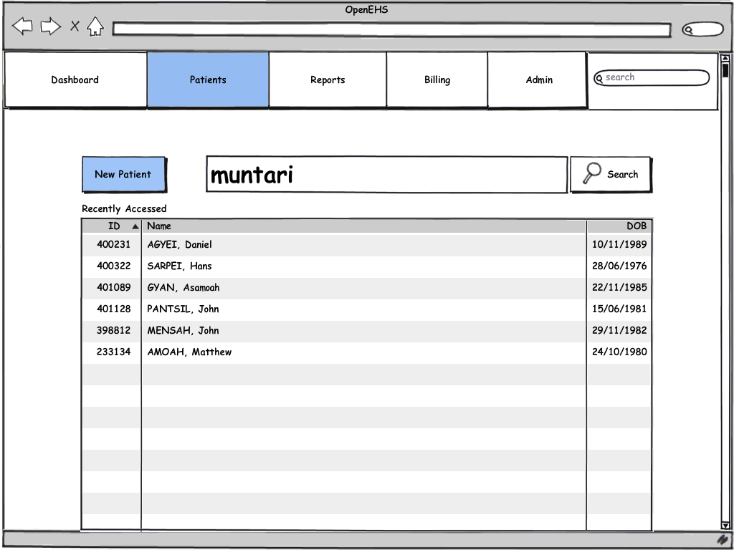

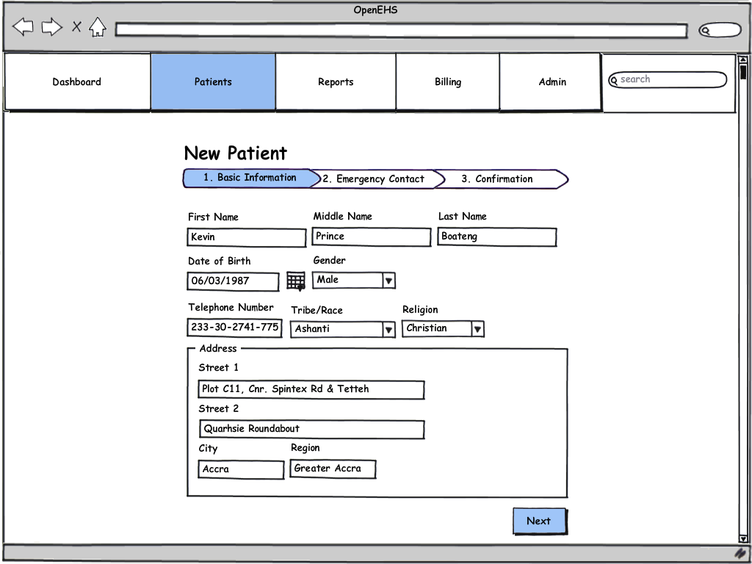

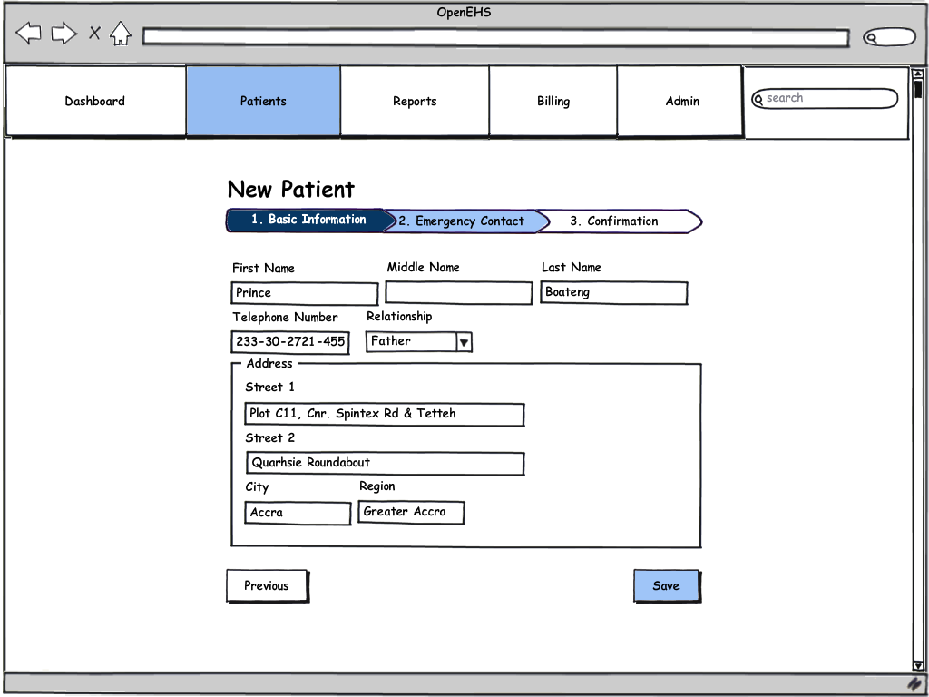

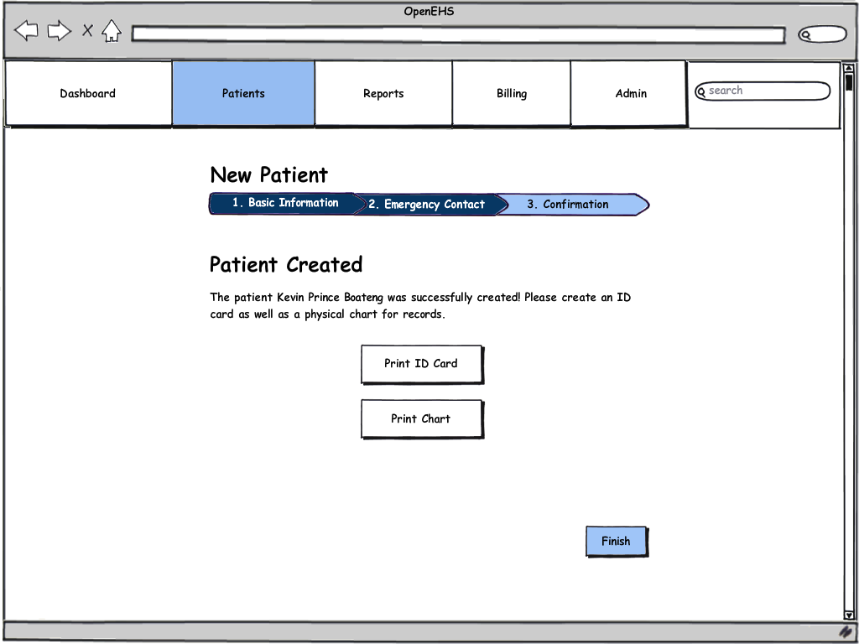

Search for Patient

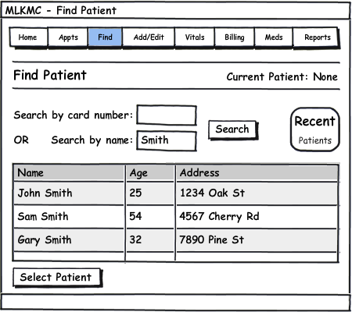

1. Click the “Find” tab to reach the Find Patient screen.
2. Enter a card ID number OR enter a first or last name.
3. Click “Search” to bring up matching results.
4. Highlight a patient by clicking the corresponding row.
5. Click “Select Patient” to select the patient.

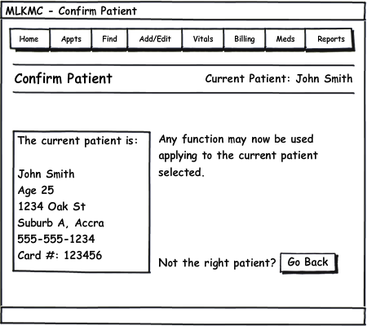

1. The current patient is now set to the user’s selection. All system tasks, when performed, will be applied to the current patient listed on the upper portion of the screen.
2. If the wrong patient was selected, click “Go Back” to return to the “Find Patient” screen.

Take Patient Vitals

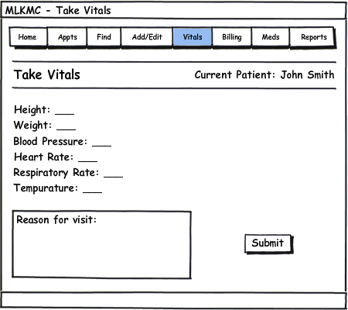

1. Click the “Vitals” tab to reach the Take Vitals screen.
2. Enter all the vital statistics, pressing Tab or clicking to reach the next field.
3. Enter a brief description of the reason for the patients visit if necessary.
4. Click “Submit” to save the information, which the physician may see now from his computer.

Issue Medications

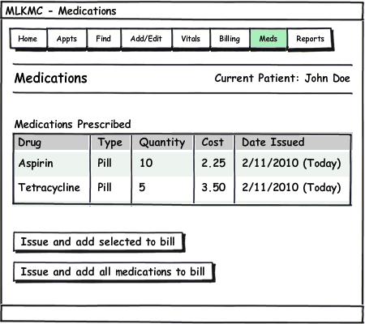

1. Click the “Meds” tab to reach the Medications screen.
2. A list of medications prescribed by the physician will be listed.
3. Click on a medication to highlight it, then click “Issue and add selected to bill” after medication has been filled. This takes the quantity of drugs out from the inventory, and also adds the cost of the drugs to the patient’s bill to be paid.
4. Or click “Issue and add all medications to bill”.

Bill Patient

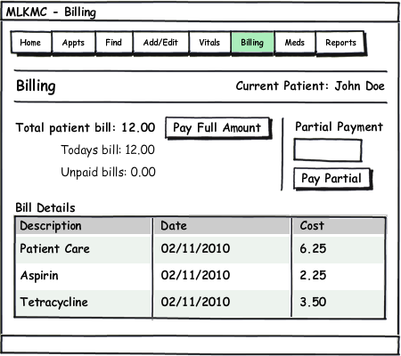

1. Click the “Billing” tab to reach the Billing screen.
2. Click “Pay Full Amount” if the patient has the money to pay the total bill.
3. Or enter an amount for partial payment, and click “Pay Partial”.

View Pharmacy Inventory Report

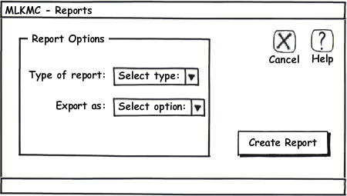

1. Click the “Reports” tab to reach the Reports screen.
2. Choose “Pharmacy Inventory Report” from the drop down list.
3. Choose a desired export option.
4. Click “Create Report”.

The report generated will be in the following form.

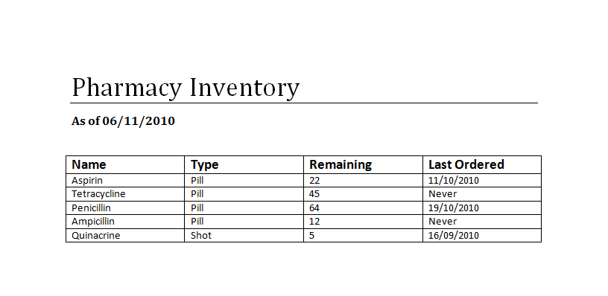

View Pharmacy Sales Report



1. Click the “Reports” tab to reach the Reports screen.
2. Choose “Pharmacy Sales Report” from the drop down list.
3. Choose a desired export option.
4. Click “Create Report”.

The report generated will be in the following form.

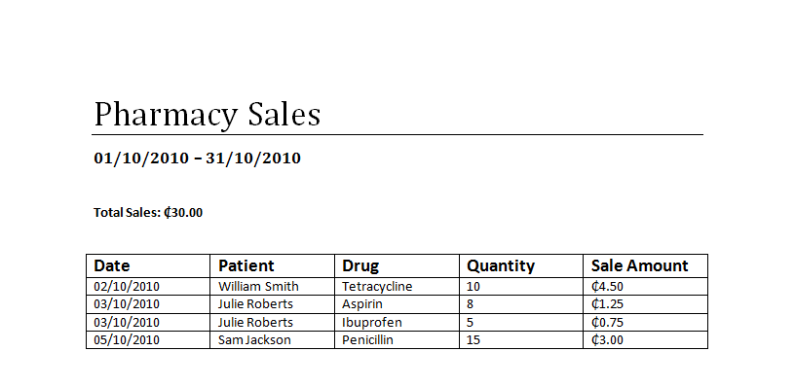

View Clinic Income Report



1. Click the “Reports” tab to reach the Reports screen.
2. Choose “Clinic Income Report” from the drop down list.
3. Choose a desired export option.
4. Click “Create Report”.

The report generated will be in the following form.

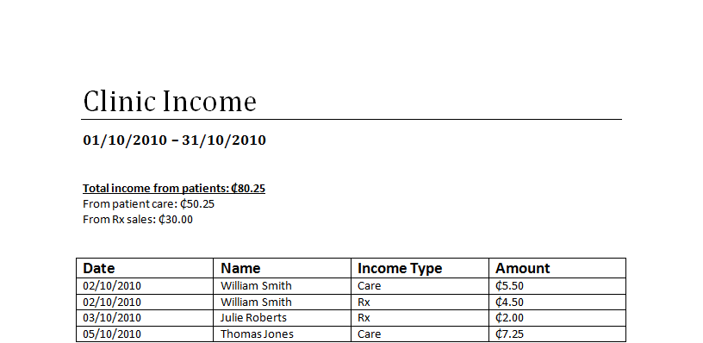

Select Patient to See

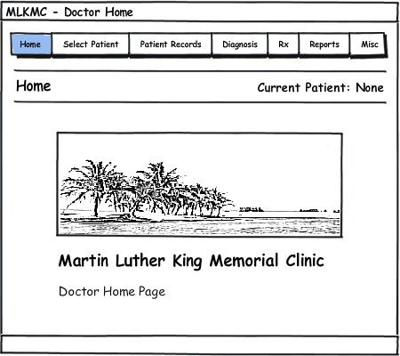

1. From the Physician Home Page, click the “Select Patient” tab on the top of the screen.

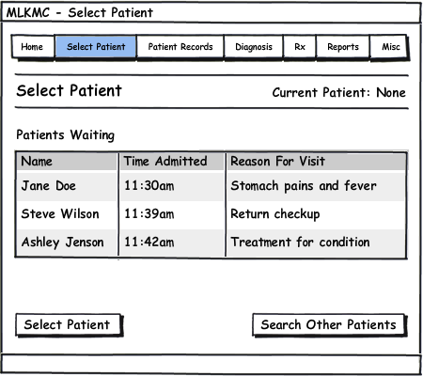

1. The patient waiting the longest amount of time will be shown and selected automatically on the top of the list.
2. Another patient may be highlighted for selection by clicking the row corresponding to their name.

Click “Select Patient” to select the highlighted patient, and begin using other system functions on them as the Current Patient.

View/Add Patient Records

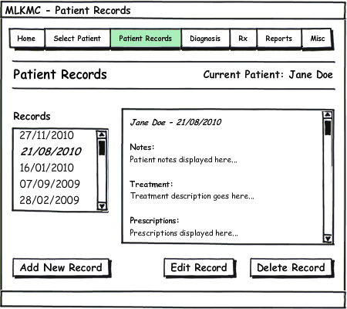

1. Click the “Patient Records” tab to reach the Patient Records screen.
2. Click the record to view from the list of dates.
3. To add a new record, click “Add New Record”.
4. Enter notes for each section of the patient record.
5. Click “Save Record” to add a new record on today’s date for the patient.

View/Make Diagnosis

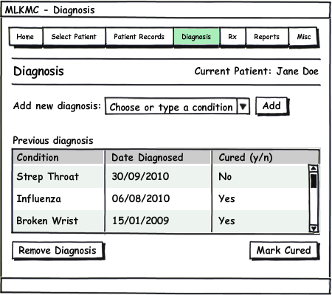

1. Click the “Diagnosis” tab to reach the Diagnosis screen.
2. Any previous diagnosis can be removed, or toggled between cured and not cured with the two lower buttons.
3. To select a new diagnosis, choose a condition or disease from the list, or type the name of the condition or disease if it is not in the list.
4. Click “Add” to add the selected diagnosis to the patient’s record.

Prescribe Medicine

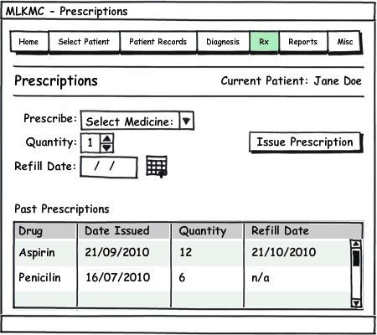

1. Click the “Rx” tab to reach the Prescriptions screen.
2. Select a medicine to prescribe from the clinic inventory by clicking In the drop down list.
3. Choose a quantity of the medicine to prescribe.
4. Select a refill date for the prescription.
5. Click “Issue Prescription” to issue the prescription to the patient. The front desk will now be able to see this prescription when the patient comes to receive it.

User Effort Estimation

Search for Patient

Navigation events to data entry events ratio is **1:3**.

1. **NAVIGATION:** total 1 mouse click, as follows
   1. Click the “Find” tab.
2. **DATA ENTRY:** total 2 mouse clicks and 1 keyboard field entry, as follows
   1. Type in Patient Card Number (or Tab to name and type name).
   2. Click “Search” (or press Enter).
   3. Click “Select Patient”.

NOTE: The above process of finding and selecting a patient can be circumvented by using the barcode scanner to simply scan the patient’s ID card.

Add Patient to System

Navigation events to data entry events ratio is **2:16.**

1. **NAVIGATION:** total 2 mouse clicks, as follows
   1. Click the “Add/Edit” tab.
   2. Click “Add New Patient”.
2. **DATA ENTRY:** total 2 mouse clicks, 7 Tabs to next field, and 7 keyboard field entries, as follows
   1. Click “Sex: Male or Female”.
   2. Tab and enter first name.
   3. Tab and enter last name.
   4. Tab and enter date of birth.
   5. Tab and enter phone number.
   6. Tab and enter house number.
   7. Tab and enter area.
   8. Tab and enter city.
   9. Click “Create Patient”.

Take Vitals

Navigation events to data entry events ratio is **1:14**

1. **NAVIGATION:** total 1 mouse click, as follows
   1. Click the “Vitals” tab.
2. **DATA ENTRY:** total 1 mouse click, 6 Tabs to next field, and 7 keyboard field entries, as follows
   1. Enter height.
   2. Tab and enter weight.
   3. Tab and enter blood pressure.
   4. Tab and enter heart rate.
   5. Tab and enter respiratory rate.
   6. Tab and enter temperature.
   7. Tab and enter the reason for visit.
   8. Click “Submit”.

Bill a Patient

Navigation events to data entry events ratio is either **1:1** or **1:3**, depending on the flow of events.

1. **NAVIGATION:** total 1 mouse click, as follows
   1. Click the “Billing” tab.
2. **DATA ENTRY:** total 1-2 mouse clicks, and 0-1 keyboard field entries, as follows
   1. Click “Pay Full Amount”.
   2. Or, if partial payment is allowed, type in the amount to pay.
   3. Click “Pay Partial”.

Select Patient to See

Navigation events to data entry events ratio is **1:1** or **1:2**, depending on the flow of events.

1. **NAVIGATION:** total 1 mouse click, as follows
   1. Click the “Select Patient” tab.
2. **DATA ENTRY:** total 1-2 mouse clicks, as follows
   1. The patient waiting the longest is automatically highlighted at the top of the list. If the physician wishes to see another patient first however, then click on that patient.
   2. Click “Select Patient” button.

Add a Patient Record

Navigation events to data entry events ratio is **2:8.**

1. **NAVIGATION:** total 2 mouse clicks, as follows
   1. Click the “Patient Records” tab.
   2. Click “Add New Record”.
2. **DATA ENTRY:** total 1 mouse click, 3 Tabs to next field, and 4 keyboard field entries, as follows
   1. Enter patient notes.
   2. Tab and enter treatment description.
   3. Tab and enter prescription.
   4. Tab and enter follow up notes.
   5. Click “Save”.

View/Make Diagnosis

Navigation events to data entry events ratio is **1:3.**

1. **NAVIGATION:** total 1 mouse click, as follows
   1. Click the “Diagnosis” tab (Diagnosis history is shown for viewing).
2. **DATA ENTRY:** total 3 mouse clicks, as follows
   1. Click on “New Diagnosis” drop down list.
   2. Click a condition or disease to select it or type in a new one.
   3. Click “Add”.

Prescribe Medicine

Navigation events to data entry events ratio is **1:8.**

1. **NAVIGATION:** total 1 mouse click, as follows
   1. Click “Rx” tab.
2. **DATA ENTRY:** total 3 mouse clicks, 2 Tabs to next field, and 3 keyboard field entries, as follows
   1. Click on “Prescribe” drop down list.
   2. Click a listed drug to select it.
   3. Tab and enter quantity.
   4. Tab and enter refill date.
   5. Click “Issue Prescription”.

Signatures

__________________________________ __________________________________  
Client Project Management